EQUIPMENT

Clothes/necessary gear | Klær/nødvendig utstyr
- long underwear, preferably woollen  - thick socks woollen  - thin socks woollen  - shirt or thin sweater woollen  - thick sweater woollen  - scarf/buff wollen  - anorak, wind jacket with hood  - winter jacket and pant if you have  - wind trousers  - raincoat (water min 10000mm)  - rain trousers  - knitted hat/warm cap without tassel  - mittens (gloves)  - wind mittens / extra mittens  - mountain boots must be water proof  - wellingtons if you have  - sunglasses  - sun protecting oil/cream (high factor)  - thermos  - sturdy knife (buy this at Stord)  - sharpening tool (buy this at Stord)  - toiletries  - warm sleeping bag (minus10 limit comfort, you can buy it on Stord)  - mountain mattress/sleeping pad  - swimmingwear  - head torch  - cutlery and plastic cup and teller  - rucksack (60 litre or more)  - insect repellent  - compass (buy it on Stord)  - waterbottle  - matches/lighter/other firestarter  - first aid kit in water proof bag containing  - All-in-one-package  - Sterile compresses  - Bandage  - Sports tape  - Compeed  - Supporting bandage  - Personal medicine | - stil-longs ull  - tjukke ullsokkar  - tynne ullsokkar  - tynn ullgenser  - tjukk ullgenser  - skjerf/bøff  - vindtett jakke med hette  - vinterjakke og bukse om du har  - vindtettbukse  - regnjakke  - regnbukse  - ull lue / varm lue uten dusk  - varme votter  - vindtette votter /ekstra par med votter  - fjellsko  - gummistøvler viss du har  - solbriller  - solkrem med høy faktor  - termos  - tollekniv (solid)  - bryne  - toalettsaker  - varm sovepose (minus 10 som komfor)  - liggeunderlag  - badetøy  - lommelykt/hodelykt  - bestikk og plastikk fat og kopp  - ryggsekk (60 liter eller mer)  - myggmiddel  - kompass  - vannflaske  - fystikker/lighter/tennstål o.l  - førstehjelpsutstyr i vanntett pose  - enkeltmannspakke  - sterile kompressar  - bandasje  - sports teip  - compeed til gangsår  - støttebandasje  - personlege medisiner

Remember:

You might come across snowstorm on the glacier and stormy weather on the sea.

Former students recommend that you by compass and knife at Stord (see picture)

Some former students have asked us to underline that it might be a good idea to buy some of the equipment in Norway. They found that quality goods were cheaper and easier to find on Stord than in The Netherlands/Denmark/Germany/England. This is especially the case with woollen clothes, rain gear, wellingtons, mountain boots and to lesser degree rucksacks and wind jacket / trousers. You do not have to bring stove and tent the school will provide this during your stay.

IF YOU HAVE YOU CAN BRING:
- leggings/gaiters * gamasjer
- books: flora, plants, mushroom
and animals in sea/seashore * bøker om flora, planter, sopp og

Compass
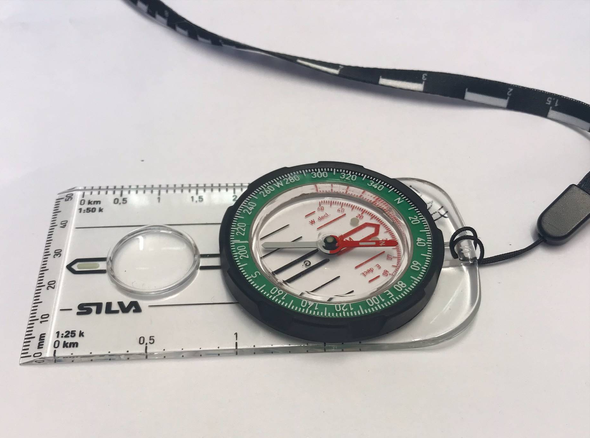

Knife

